## PRODUCT DEMAND PREDICTION WITH MACHINE LEARNINGS

**TEAM MEMBER**

**911721104005 : ABINAYA C**

**Phase 4 Submission Document**

**Project:** Product Demand Analysis

**Phase 3:** Development Part 2



### **PRODUCT DEMAND PREDICTION**

Problem Definition:

The problem is to develop a machine learning model that can predict product demand based on historical sales data and external factors.

This model will help businesses optimize their inventory management and production planning to meet customer needs efficiently.

The project will involve data collection, data preprocessing, feature engineering, model selection, training, and evaluation.

**INTRODUCTION**

Feature engineering is the process of selecting, manipulating, and transforming raw data into features that can be used in supervised learning. In order to make machine learning work well on new tasks, it might be necessary to design and train better features. As you may know, a “feature” is any measurable input that can be used in a predictive model — it could be the color of an object or the sound of someone’s voice. Feature engineering, **in simple terms, is the act of converting raw observations into desired features using statistical or machine learning approaches.**

In this project we will see :

* What is Feature engineering,
* Importance of Feature Engineering,
* Feature Engineering Techniques for Machine Learning,
* Few Best tools for feature engineering.

# **What is Feature Engineering**

Feature engineering is a machine learning technique that leverages data to create new variables that aren’t in the training set. It can produce new features for both supervised and unsupervised learning, with the goal of **simplifying and speeding up data transformations** while also **enhancing model accuracy**. Feature engineering is required when working with machine learning models. Regardless of the data or architecture, a terrible feature will have a direct impact on your model.

**IMPORTING LIBRARIES**

In [58]:

*# Import necessary libraries*

import pandas as pd

from sklearn.model_selection import train_test_split

from sklearn.preprocessing import StandardScaler

**DATA COLLECTION**

In [59]:

*# Data Collection*

*# Assuming your dataset is named 'product_demand_data.csv' and located in the same directory as your Python script*

data = pd.read_csv('/content/PoductDemand.csv')

**DATA PREPROCESSING**

In [60]:

*# Data Preprocessing*

*# Handling Missing Values (if any)*

data.fillna(0, inplace=True)

In [61]:

data.isnull().sum()

Out[61]:

ID 0

Store ID 0

Total Price 0

Base Price 0

Units Sold 0

dtype: int64

SPLIT DATA

In [62]:

*# Data Transformation*

*# No categorical variables to encode in this case*

*# Split Data*

X = data[features] *# Features*

y = data[target] *# Target variable*

*# Split the data into training and testing sets (70-30 split)*

X_train, X_test, y_train, y_test = train_test_split(X, y, test_size=0.3, random_state=42)

*# Data Standardization (optional, but often necessary for many machine learning algorithms)*

scaler = StandardScaler()

X_train = scaler.fit_transform(X_train)

X_test = scaler.transform(X_test)

**Encode categorical data**

In [63]:

import numpy as np

import pandas as pd

*# One-hot encode the categorical data*

encoded_df = pd.get_dummies(data)

*# Print the encoded DataFrame*

print(encoded_df)

ID Store ID Total Price Base Price Units Sold

0 1 8091 99.0375 111.8625 20

1 2 8091 99.0375 99.0375 28

2 3 8091 133.9500 133.9500 19

3 4 8091 133.9500 133.9500 44

4 5 8091 141.0750 141.0750 52

... ... ... ... ... ...

150145 212638 9984 235.8375 235.8375 38

150146 212639 9984 235.8375 235.8375 30

150147 212642 9984 357.6750 483.7875 31

150148 212643 9984 141.7875 191.6625 12

150149 212644 9984 234.4125 234.4125 15

[150150 rows x 5 columns]

FEATURE SELECTION

In [64]:

*# Feature Selection*

features = ['ID', 'Store ID', 'Total Price', 'Base Price'] *# Features*

target = 'Units Sold' *# Target variable*

**Histograms and Box Plots:**

In [65]:

import matplotlib.pyplot as plt

*# Histograms*

data[features].hist(bins=20, figsize=(12, 10))

plt.suptitle("Histograms of Features")

plt.show()

*# Box Plots*

data[features].plot(kind='box', vert=False, figsize=(12, 6))

plt.title("Box Plots of Features")

plt.show()

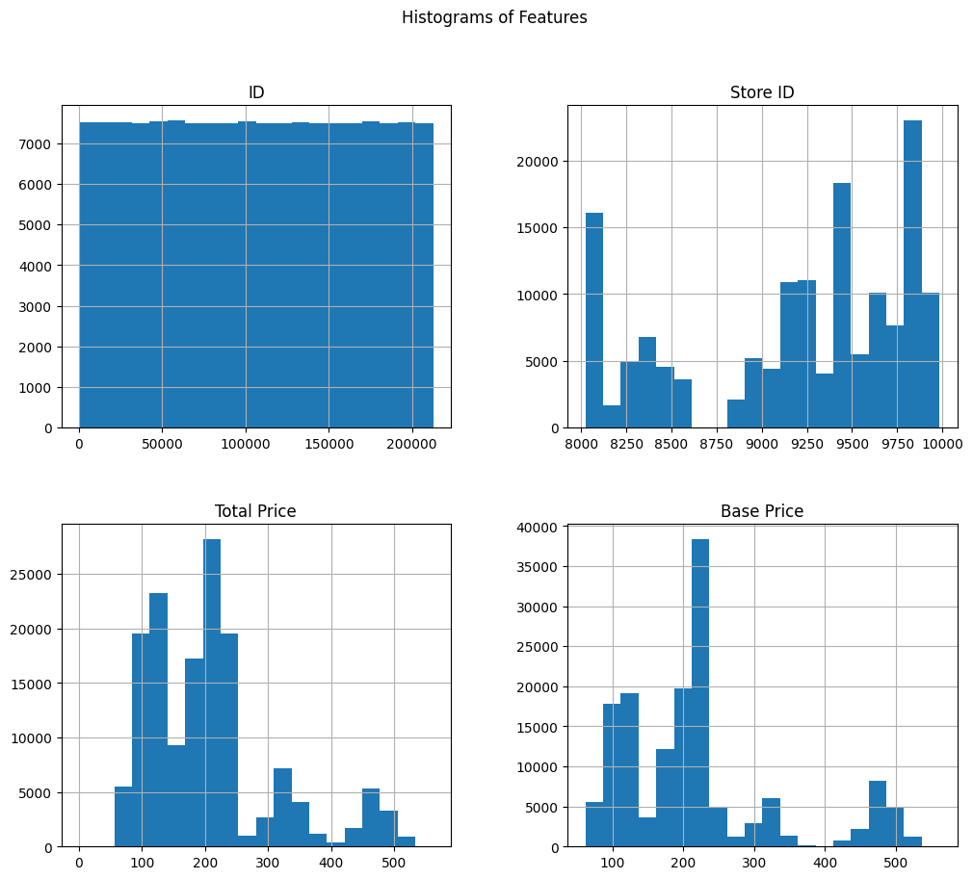

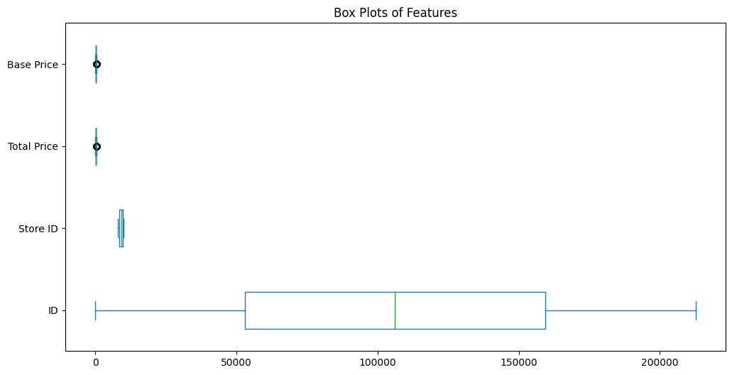

**Correlation Matrix:**

In [66]:

import seaborn as sns

correlation_matrix = data[features].corr()

sns.heatmap(correlation_matrix, annot=True, cmap='coolwarm')

plt.title("Correlation Matrix")

plt.show()

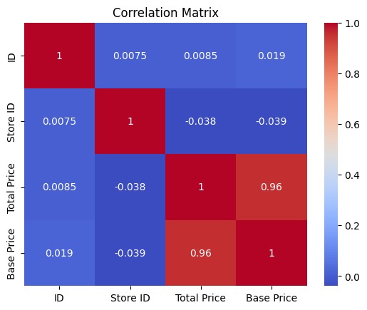

**Pair Plot:**

In [67]:

sns.pairplot(data[features])

plt.suptitle("Pair Plot of Features")

plt.show()

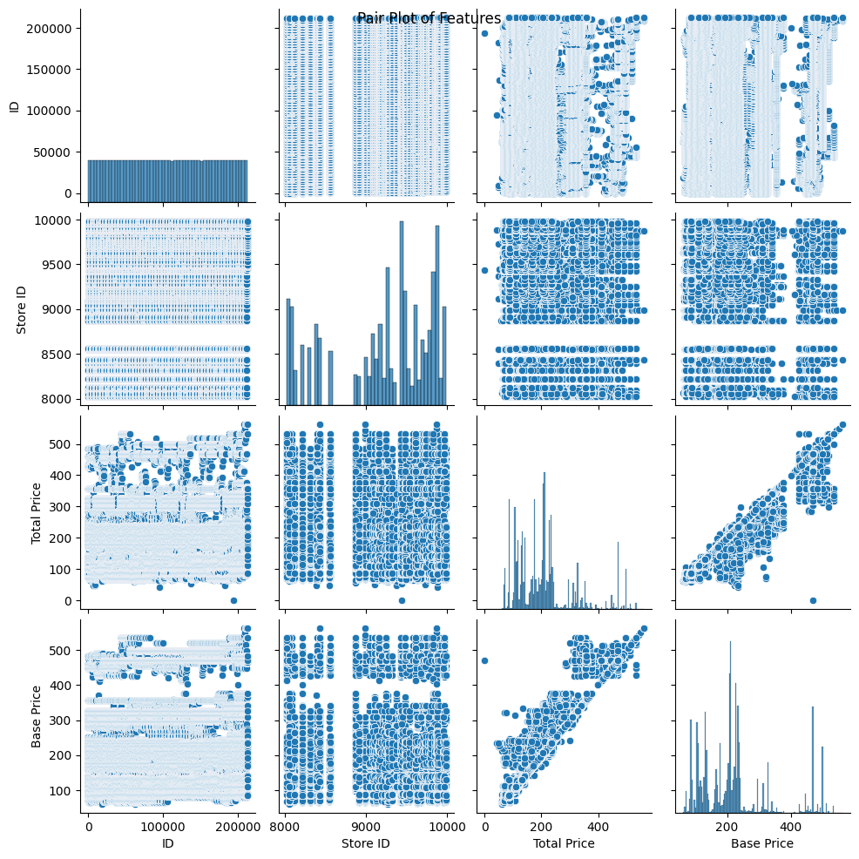

**Target Variable Distribution:**

In [68]:

plt.figure(figsize=(8, 6))

sns.histplot(data[target], bins=20, kde=True)

plt.title("Distribution of Target Variable")

plt.xlabel(target)

plt.ylabel("Frequency")

plt.show()

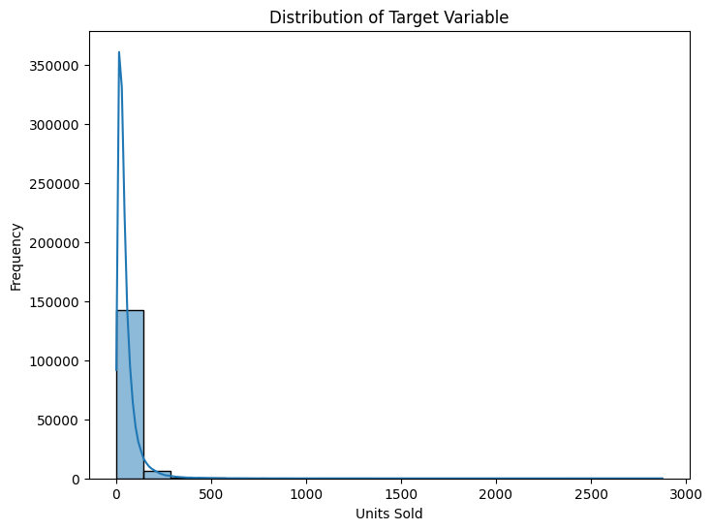

**Feature vs. Target Plots:**

In [69]:

for feature in features:

plt.figure(figsize=(8, 6))

sns.scatterplot(x=data[feature], y=data[target])

plt.title(f"{feature} vs. {target}")

plt.xlabel(feature)

plt.ylabel(target)

plt.show()

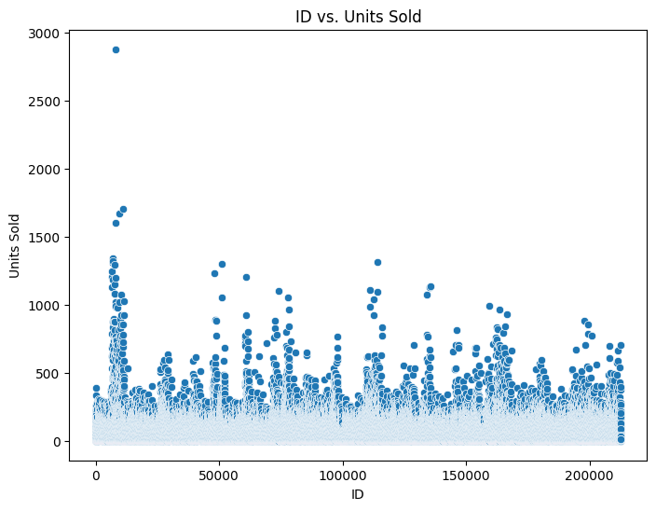

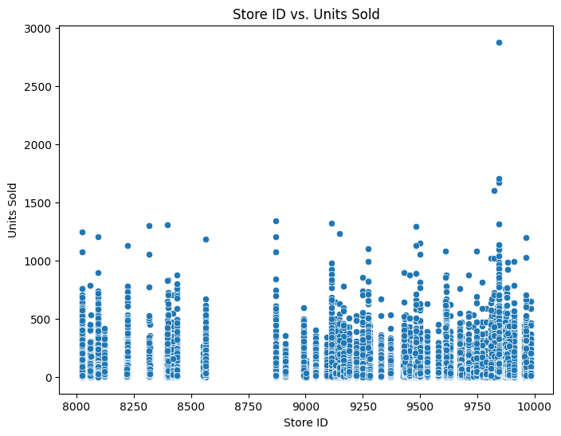

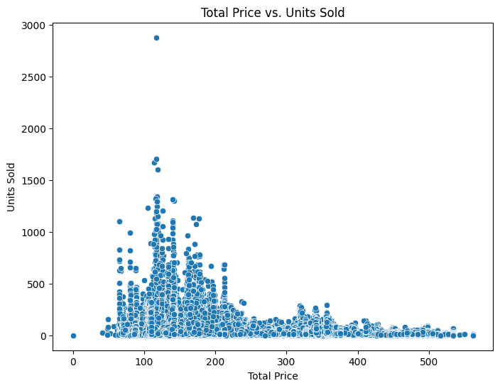

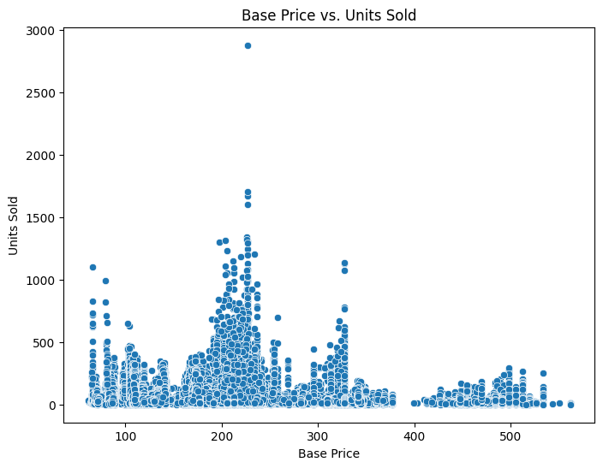

Box Plot of Target Variable Grouped by Categorical Feature

In [70]:

categorical_feature = 'Store ID' *# Example categorical feature*

plt.figure(figsize=(10, 6))

sns.boxplot(x=categorical_feature, y=target, data=data)

plt.title(f"Box Plot of {target} Grouped by {categorical_feature}")

plt.xlabel(categorical_feature)

plt.ylabel(target)

plt.xticks(rotation=45)

plt.show()

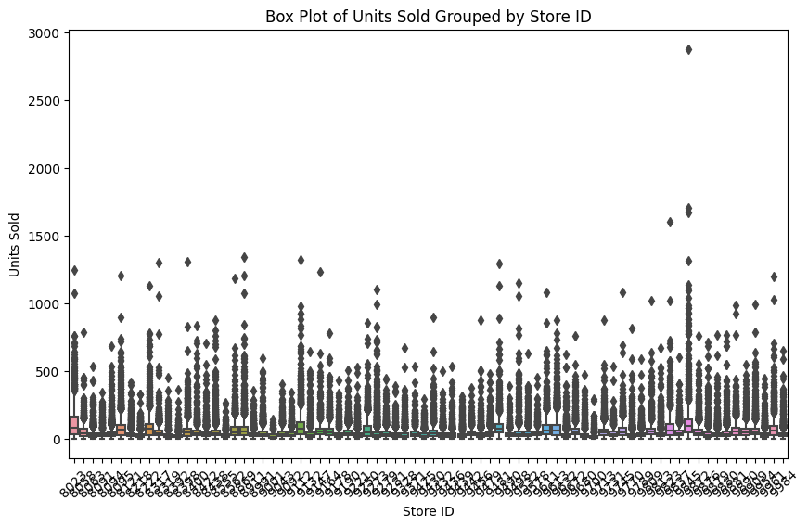

MODEL SELECTION

In [15]:

*# Import necessary libraries for different algorithms*

from sklearn.linear_model import LinearRegression

from sklearn.ensemble import RandomForestRegressor, GradientBoostingRegressor

from sklearn.svm import SVR

from sklearn.metrics import mean_squared_error, r2_score

*# Initialize models*

linear_reg = LinearRegression()

random_forest = RandomForestRegressor(random_state=42)

svm = SVR()

gradient_boosting = GradientBoostingRegressor(random_state=42)

*# Train and predict using each algorithm*

models = [linear_reg, random_forest, svm, gradient_boosting]

model_names = ['Linear Regression', 'Random Forest', 'Support Vector Machine', 'Gradient Boosting']

for model, name in zip(models, model_names):

model.fit(X_train, y_train)

predictions = model.predict(X_test)

mse = mean_squared_error(y_test, predictions)

r2 = r2_score(y_test, predictions)

print(f"Model: {name}")

print(f"Mean Squared Error: {mse:.2f}")

print(f"R-squared: {r2:.2f}")

print("-" * 30)

Model: Linear Regression

Mean Squared Error: 2844.00

R-squared: 0.15

------------------------------

Model: Random Forest

Mean Squared Error: 1156.38

R-squared: 0.66

------------------------------

Model: Support Vector Machine

Mean Squared Error: 2956.17

R-squared: 0.12

------------------------------

Model: Gradient Boosting

Mean Squared Error: 1885.63

R-squared: 0.44

------------------------------

# **CONCLUSION**

Random Forest and Gradient Boosting model typically perform well in a variety of datasets due to their ability to capture complex patterns in the data.

Support Vector Machine (SVM) might perform well if the dataset has high dimensionality and complex relationships, although it might require fine-tuning of hyperparameters for optimal results.

Linear Regression provides a basic understanding of the relationships between variables but might not capture intricate patterns present in the data.